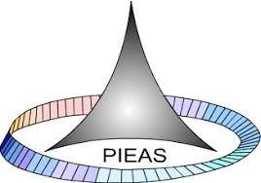

PAKISTAN INSTITUTE OF ENGINEERING AND APPLIED SCIENCES

***Computing Fundamentals & Programming***

**FALL 2020**

**Laboratory Exercise-14**

**Department: Physics**

**Name: Umar Shifaqat**

**Serial No. 43**

**Roll No. BS-20-GB-100864**

**Date: January 04, 2021**

**Task 1**

Write a program in C to calculate the sum of array elements by passing to a function.

**INPUT**

#include<stdio.h>

int add(int a[2][3]);

int main()

{

int a[2][3],sum;

int i,j;

puts("Enter 6 elements of the 2-D array:");

for(i=0;i<2;i++)

for(j=0;j<3;j++)

scanf("%d",&a[i][j]);

sum=add(a);

printf("\nThe sum of all elements of the 2-D array is is %d",sum);

getchar();

getchar();

return 0;

}

int add(int a[2][3])

{

int i,j,sum=0;

for(i=0;i<2;i++)

for(j=0;j<3;j++)

sum+=a[i][j];

return sum;

}

**OUTPUT**

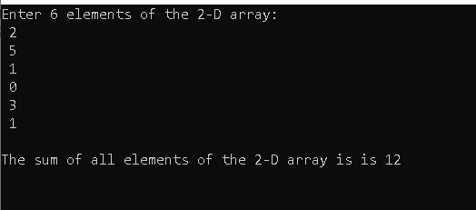

**Task 2**

Write a definition of function sum(A,n) which takes an array if ints A and its logical size n and returns the sum of all of the integers in the array.

**Function Definition**

int sum(int A[],int n)

{

int i,sum=0;

for(i=0;i<n;i++)

sum+=A[i];

return sum;

}

**THE END**